Acacia Mittens (adaptation of Acacia Fingerless Mittens)
Create July 6, 2016, by sldeskins - work in progress revision 0
(supplement to: http://crochetvolution.com/archives/winter-2012/acacia-cowl-and-fingerless-mittens)
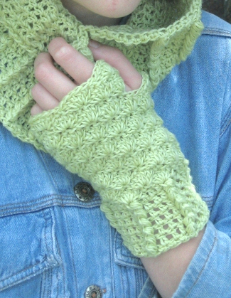
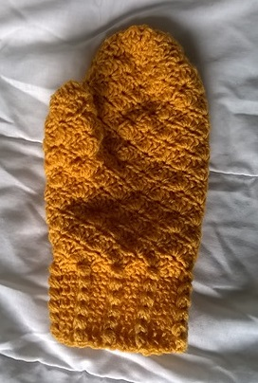
I thought this was a nice pattern,
and wanted full mittens. Current only
adapted for XS and L.

Mittens
Leaving a long tail and using fdc, make 20 (24, 28, 32) sts. On last fdc (yo and insert hook into 'chain' of prior stitch and first stitch, complete stitch.) Join with a sl st to form a ring.
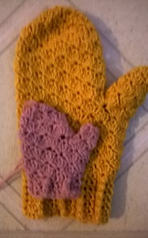
Acacia Ribbing
[4 stitch repeat = 1dc, 1FPPS, 2 dc]
x (5, 6, 7, 8)

Rnd 1: Ch 3 (counts as dc), dc into next st. *FPPS around next st, dc into next 3 sts. Repeat from * to last 2 sts, FPPS around next st, dc into last st, sl st into beginning dc to join.
Pattern
Rnd 2: Ch 3 (counts as dc), dc into next st. *FPPS around post of FPPS, dc in next 3 sts. Rep from * to last 2 sts, FPPS around post of FPPS, dc in last st, sl st into beg dc to join.
Rnd 3 – 6: Repeat Rnd 2 for desired cuff length.

Shell Pattern
alternating rows of
[sc, fan ] x (5, 6, 7, 8)
[fan, sc ] x (5, 6, 7, 8)

Rnd 7: position thread ch1, sc in dc(ch3) of last round- this counts as the sc. *fan in top of FPPS, sk 1 st, sc in next st, sk 1 st,* Rep from * to last st, sk 1 st,
sl int beginning sc.

Rnd 8 [fan, sc]: Ch 3 (counts as dc), make 4 dc in same st. *Sk 1st 2 dc of fan, sc in 3rd dc of fan, sk last 2 dc of fan, fan in sc. Rep from * to last 5 sts, sk 1st 2 dc of fan, sc in 3rd dc of fan, sl into top of dc(ch3) at the beginning of the round.

Rnd 9 [sc, fan]: Sl st across 1 st, ch1, sc in 3rd dc of fan. *fan in sc, sk 1st 2 dc of fan, sc in 3rd dc of fan* Rep from * to last 2 sts, sk 2 dc, sl into beginning sc.

Rep Rnds 8 & 9 alternately another 2 (2, 3, 3) times each, ending with Rnd 9.
Rnd 14, (14, 16, 16): Sl st across 2 sts, sc in 3rd dc of fan, ch 5, sk next (sc, fan and sc), sc in 3rd dc of next fan, *sk last 2 dc of fan, fan in sc, sk 1st 2 dc of fan, sc in 3rd dc of fan. Rep from * to last 5 sts, sk last 2 dc of fan, fan in sc, sk 1st 2 dc of fan, sl st into beg sc to join. (4, 5, 6, 7 fans, 4, 5, 6, 7 sc).
Rnd 15, (15, 17, 17): Ch 3(counts as dc), make 4 dc in same st, sk 2 ch, sc in 3rd ch, sk 2 ch, fan in sc, *sk 1st 2 dc of fan, sc in 3rd dc of fan, sk last 2 dc of fan, fan in sc. Rep from * to last 5 sts, sk 1st 2 dc of fan, sc in 3rd dc of fan, sl st in 3rd ch of beg ch-3 to join.
Rnd 16,(16, 18, 18): Rep Rnd 8.
Rnd 19 (Medium and Large sizes only): Rep Rnd 9.
Rnd 20 (Large size only): Rep Rnd 8.

Thumb
Work 2 (2, 3, 3) [shells] depending prior rnd.
2 shells: 2- 7dc fans
3 shells: 1- 7dc fan, 1- 5dc fan, 1- 7dc fan

if prior round 9, sc, go to beginning fan and make sc like other earlier row joins.

XS/S – cross gap with ch1 (2 repeats)
continue with 5dc shell pattern until within 3/4” of finished length
Thumb decrease
1 rnd shell, with 4 dc fan.
1 rnd shell with 3 dc fan, 6 stitches. Finish – leave long tails and sew to close.

M/L, chain 5 and join on the other side of the mitten. if prior round 9, sc, go to beginning fan and make sc like other earlier row joins.
M/L – join at dip, 7dc fan, sc, 7dc fan.
2 – 7dc shell, near thumb all other shells 5dc
1 - 7 dc shell, near thumb all other shells 5dc
Repeat 5dc shell pattern until about 1-1/2” of length remains.
Thumb decrease
2 rnds - shell, with 4 dc fan.
1 rnds - shell with 3 dc fan, 12 stitches.
4 dc decrease, 3 times – 3 stitches. Finish – leave long tails and sew to close.

Mitten Top
Join at the base of the thumb, in the center of the gap
If the base of the thumb is at the top of a fan join with a sc.
If the base of the

XS – join at dip, 7dc fan, sc, 7dc fan.
2 – 7dc shell, near thumb all other shells 5dc
1 - 7 dc shell, near thumb all other shells 5dc
5dc shell pattern
Repeat 5dc shell pattern until about 1-1/2” of length remains.

Shape to mitten decrease
2 -4dc, near thumb all other shells 5dc
4dc shell all around
3dc shell all around -16 stitches
4 dc decrease, 4 times – 4 stitches
draw loop throw remain 4 stitches, leave a long end, sew to close.

L – join at dip, 7dc fan, sc, 7dc fan.
2 – 7dc shell, near thumb all other shells 5dc
1 - 7 dc shell, near thumb all other shells 5dc

Repeat 5dc shell pattern until about 2” of length remains.

Shape to mitten decrease

Place markers on thumb side and opposite side.
Keeping in pattern on next rnds
even rnd at marker : 4- 4 (fan)
odd rnd at marker : 4-5-4 (fan)
even rnd at marker : 4-4, 4-4 (fan)
odd rnd at marker : 4-3-4-3-4(fan)
even rnd at marker : 4-3-4-3-4(fan)
odd rnd at marker : 2 (fan) all around
4 dc decrease
draw loop throw remain 4 stitches, leave a long end, sew to close.

FINISHING
Wash and block as needed.

http://crochetvolution.com/archives/winter-2012/acacia-cowl-and-fingerless-mittens

Gauge: 16 sts/13 rows = 4″/10cm in FPPS pattern

Special Stitches
Front Post Puff Stitch (FPPS): *YO, insert hook around post of indicated stitch, from front to back to front, YO, draw loop through. Repeat from * 3 more times, YO, draw through all 9 loops on hook; ch 1 to close. (This ch-1 doesn’t count as separate st, it is part of the FPPS).
(Tip: To place your FPPS when it says FPPS around FPPS: I found that by holding the FPPS between 2 fingers just at the top of all the ‘puffy’ stitches, you can see a bit of the post. This is where you put your hook around and work your FPPS around this bit of the post, the same way you worked it around the tr in the first round.)

Foundation Double Crochet (fdc): Ch 3, YO, insert your hook through 3rd ch from hook, YO, draw through, YO, draw through 1 loop (this creates your ch). (YO, draw through 2 loops) twice. This makes your first st. 2nd and subsequent sts: YO, insert your hook through the ch part of previous st, YO, draw through, YO, draw through 1 loop. (YO, draw through 2 loops) twice.

Fan: Make 5 dc in the same st, unless otherwise directed.

Shell Pattern:
When the fan below has even number dc, sc in the gap at the center.
When the fan below has odd number dc, sc in the center dc.

